**GROUP ASSIGNMENT**

**TECHNOLOGY PARK MALAYSIA**

**AINT008-4-2-I3D**

**INTRODUCTION TO GRAPHICS AND 3D APPLICATIONS**

**UCDF2304ICT(ITR)**

**HAND OUT DATE: 13th March 2024**

**HAND IN DATE: 20th May 2024**

**MODULE LECTURER: HAMZAH MOHD KHARIR**

**INSTRUCTION:**

1. **Submit your assignment in the APU Moodle.**
2. **Students are advised to underpin their answers with the use of references (cited using the APA System of Referencing).**
3. **Late submission will be awarded zero (0) unless Extenuating Circumstances (EC) are upheld.**
4. **Cases of plagiarism will be penalized.**

|  |  |
| --- | --- |
| **Student Name** | **TP Number** |
| Ng Jun Yuan | TP067314 |

Table of Contents

Workload Matrix 3

Objectives and aim of my 3D animation 4

Targeted users in my 3D video 5

Summary of what I have done 6

The problems I encountered and how to fix them 7

Forming knife’s blade shape issues 7

Texture issues 9

The screen layout (storyboard and storyline) 12

Special features in my animation 15

References 16

# Workload Matrix

|  |  |  |  |
| --- | --- | --- | --- |
| Name | TP number | Workload | Sign |
| NG JUN YUAN | 067314 | All | Ng Jun yuan |

# Objectives and aim of my 3D animation

The objective of my 3D animation is show how good this knife is. In this 3D video, the handle and blade of the knife are mainly shown, and the details of the knife are shown through different lighting and camera scenes.

The aim of my 3D animation is attracting targeted users in this knife, this video of this knife is a advertisement to let the public know about the existence of this knife in the market. At the same time, the kitchen knife shown in the video also facilitates target users to compare other knives on the market and attracts target customers to choose the knife in the video.

(Melendez, 2020)

# Targeted users in my 3D video

The targeted user in my 3D video is chef and housewife. The knife in is 3D video is a chef knife, which is an indispensable knife for handling western food, whether it is fish, meat, or vegetables. It can’t cut bones and the food which are hard.

# Summary of what I have done

In this 3D assignment, I done the following effect in my assignment video:

* Lighting with 3-point setting, they are key light, fill light and back light.
* Have different camera view in different position of the knife in video.
* Uses a box, a cylinder and 6 sphere make the knife as an object.
* Set the texture in knife and have different materials in different parts.
* Light direction will move together with camera.
* Shadows is on in key light only.
* This video is 6 scenes combined as a video with 1 background music.
* Each scenes camera and all light will move based on setting.

# The problems I encountered and how to fix them

## Forming knife’s blade shape issues

Figure 1: The shape for the knife’s blade messes up

Figure 2: The knife’s blade curves on the front and back are uneven

Figure 3: The knife’s blade back after wrong process

Figure 4: The knife’s blade vertices with right way to adjustment

The knife’s blade using a picture as a background, then draw a box with adjustment vertices and using extrude to make the full shape of the knife’s blade. When adjusting the vertical in front, the same edge in the back vertical did not been selected together adjusting and cause phenomenon in Figure 1, Figure 2, and Figure 3.

To fix this problem, I decided to re-model and adjusting in Front view. In Front view, just choose one vertical and the following same vertical in back with same edge will adjust together and the outcome look in Figure 4.

## Texture issues

Figure 5: The texture stretched after applied in Knife’s blade.

Figure 6: The texture did not apply the detail in the handle of the knife.

In Figure 5 and Figure 6, I am using Material Editor to apply the texture into the object with PNG format picture, but it does not apply nicely. In Figure 5, the texture stretched in long range in the knife’s blade. In Figure 6, the texture applies in knife’s handle with main colour form the picture only.

Figure 7: The texture no stretched anymore in knife’s blade.

Figure 8: The texture has detail in the handle of the knife.

Figure 9: UVW Map

A way to solve the issues in Figure 5 and Figure 6 is select the object needs to fix, open UVW Map in Figure 9 and in Parameters, inside had a zone for Mapping and choose Box. After that, the texture in Figure 5 become Figure 7 and Figure 6 become Figure 8.

# The screen layout (storyboard and storyline)

Figure 10: The first scenes storyboard of the video

For this storyline, it shows the handle for the knife with turn the view for the handle to another side, which show the handle build quality.

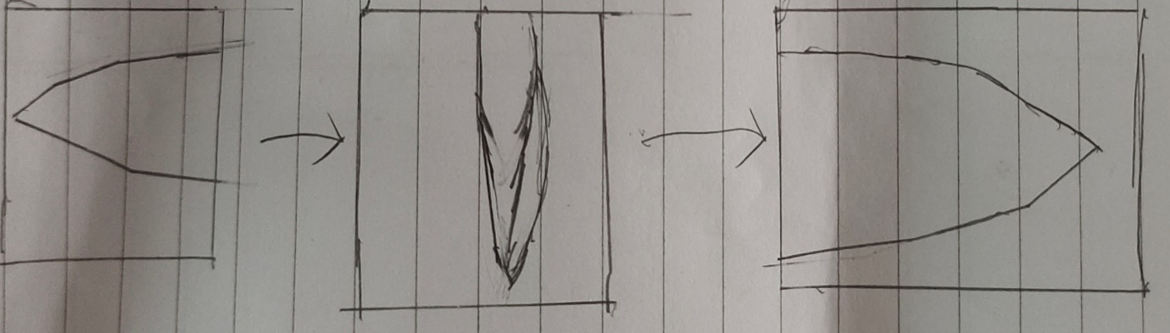

Figure 11: The second scenes storyboard for the video

For this storyline, turn the camera in front knife's blade form right to left with a slow move when pass the front of the blade to show the sharpness of the front of the knife.

Figure 12: The third scenes storyboard for the video

For this storyline, move the camera in knife's blade below part in front to the back to show the sharpness of the blade at the contact surface between the knife and the food.

Figure 13: The fourth scenes storyboard for the video

For this storyline, move the camera from the left and get close to the blade, then turn to the right and get more closer the blade to show the structure of this knife.

Figure 14: The fifth scenes storyboard for the video

For this storyline, move the camera form left to right with go through perspective form above to show the structure of the joint between the handle and the blade.

Figure 15: The last scenes storyboard for the video

For this storyline, move the camera rotate 180 degrees to reveal the entire knife.

# Special features in my animation

Figure 16: The camera is linked to the curve line

Figure 17: The camera has followed the curve line to move in different frames

I am using NURBS function with CV Curve to make a curve line and the curve line move together with camera by Path constraint function in Constraints, which show in Figure 16 and Figure 17.

When changing the camera angle, you can directly change the vertices of the curve. Compared with adding keyframe pairs to adjust the camera angle, the camera angle adjusted using this method will be more accurate and it is easier to determine the route of the camera lens.

This special feature used in the fifth and sixth scenes of my 3D video.

# References

Games, N. (17 March, 2015). *YouTube*. Retrieved from 3DS Max Problem Solving - Texturing Issues: https://www.youtube.com/watch?v=apmgji9vTbE

HONMYUE. (n.d.). *HONMYUE*. Retrieved from HONMYUE: https://www.textile-hy.com.tw/chs/%E4%B8%B9%E5%AE%81-%E5%8D%95%E5%AE%81%E5%B8%83.htm#con_2522

Karai, K. (1 March, 2017). *YouTube*. Retrieved from Tutorial on Modeling a Kitchen Knife in 3dsmax.: https://www.youtube.com/watch?v=2Fa3Ex8ti8s&t=180s

Khoshpayam, A. (27 October, 2022). *YouTube*. Retrieved from 3ds Max Tutorial: Remove Edges: https://www.youtube.com/watch?v=IVSxHE-9Nag

Melendez, F. (24 April, 2020). *YouTube*. Retrieved from 3ds Max - Animation - Camera Path: https://www.youtube.com/watch?v=XJshbS6XjMY

Qin, Q. (11 November, 2016). *YouTube*. Retrieved from Edit a sphere in 3Ds Max Poke Ball part 1: https://www.youtube.com/watch?v=FW3Lz7EnAsA&t=241s